Team Project: Secure Network Expansion (Single Solution Focus)
Due: Monday, May 11th, 2026 – End of day Worth: [20%]
Policy: No late submissions accepted.

Project Overview
In established groups of 2, you will create a network topology based on a client interview and main site inventory. The goal is to design a robust on-premise expansion for a medical facility.
The audit document must include the following sections:
- Actual Situation
- Solution / Recommendation
- Conclusions
- Appendix
  - Terms and definitions
  - Network diagrams
  - Inventory List
Document Requirements
- Length: The body of the document (excluding the title page, table of contents, and any appendices) should be 3 to 4 pages in length.
- Focus: Quality is more important than quantity.
- Scope: Only one comprehensive solution will be proposed to the client.

Project Hypotheses
- Workstations: Each employee has a computer, except in the laboratory where computers are shared.
- Tools: Use network elements available in Cisco Packet Tracer.
- Connectivity: For diagramming purposes, the internet connection is considered a Cloud connection.
- Procurement: Prices for all upgrades or replacements must be checked on Canadian websites only.

Deliverables & Grading
Deliverable | Weight
Proposal Document: The proposal document with all required appendices. | 25%
PowerPoint Presentation: A presentation detailing the proposed solution scenario. | 10%
Oral Presentation: 15-minute presentation during the last two days of class. | 10%
Technical Implementation: The Packet Tracer diagram of the chosen solution named Team#_Net_s#.pka. | 50%
Evaluation: Self and peer evaluation document filled by each student. | 5%

Note:
Each student must submit the full project package on Lea in a zip file. (Will extract 20% for not submitting all the files in the deliverable table).
Approved department attendance policy
- In class group work or project integration activities:
Absences that amount to more than 20% of the hours associated with any of these activities will result in a grade of zero on the assessment related to the missed activity, unless the absences have been deemed excused absences as per the IPESA.

Client Interview: "HealthyLife Specialists"
Q: Why do you need our services? What are the problems with your current network?
A: We are planning an expansion and bought a new location approximately 12 km away from our main site. Our current network struggles with the massive imaging files we generate.
Q: What are the requirements for the new location?
A: There is a constant need to connect to our high-resolution imaging database and the Patient Management System (PMS) hosted on our main servers.
Q: What services are currently hosted on your servers?
A: We host the PMS, a secure patient record database, and a lab result portal. Because our scans are high-detail, we are quickly running out of storage space.
Q: How do the servers perform?
A: Services are stable, but we experience lag during large file transfers and don't know the cause.
Q: What is your stance on Cloud technologies?
A: We are not interested in cloud for this expansion. We require all primary data and infrastructure to be kept on-site due to strict medical privacy regulations and the physical size of our files. We prefer investing in hardware we own and maintain locally.
Q: Do you require Wi-Fi?
A: Yes, we need secure Wi-Fi for staff tablets and a separate guest network for patients at the new location.
Q: Other services that will use the connection?
A: Our doctors work on a hybrid schedule and need to review charts from home. It is essential to have secure VPN capabilities.
Q: How many departments and employees do you have?
A: Admin/Reception (4), Doctors (10), Nurses (16), Lab Techs (20), IT (2). The new location will add half the size of our current staff.

Main Site Inventory
- Internet: 1Gbps Fiber
- Security: Cisco Firepower Firewall
- Switching: 2x 48-port Managed Switches
- Routing: 2x Routers (Internal and VoIP)
- IP Phones: 25 Devices
- Workstations: 35x Windows 11 Desktops
- Server: HP ProLiant (12 core, 32 GB RAM, 2TB RAID 10)
- Storage: 6TB NAS (RAID 5)

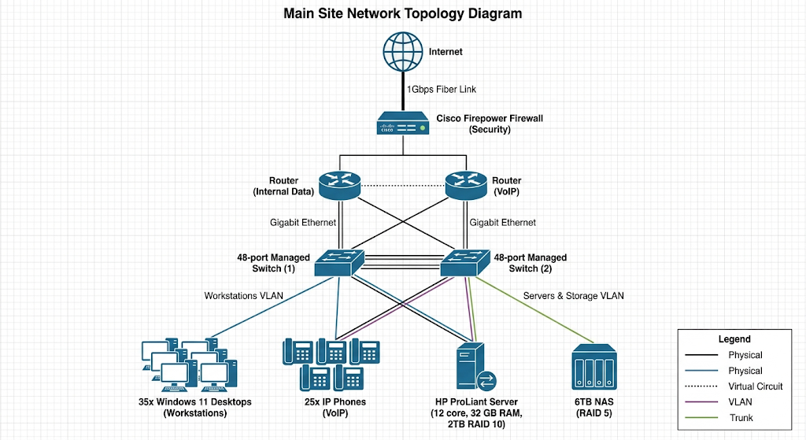

Self / Peer Evaluation
Team Number: ______________ Your Name: ___________________________________
 | Rarely | Sometimes | Mostly | Always
Did a fair share of the work involved
Was cooperative / completed their allocated task(s)
Contributed to ideas / planning / preparation
Was positive and helpful throughout

Partner name _____________________________________
 | Rarely | Sometimes | Mostly | Always
Did a fair share of the work involved
Was cooperative / completed their allocated task(s)
Contributed to ideas / planning / preparation
Was positive and helpful throughout

